**A000-ME-Israel-Lower Paleolithic Figurine-Silicified Sandstone-200,000 BCE**

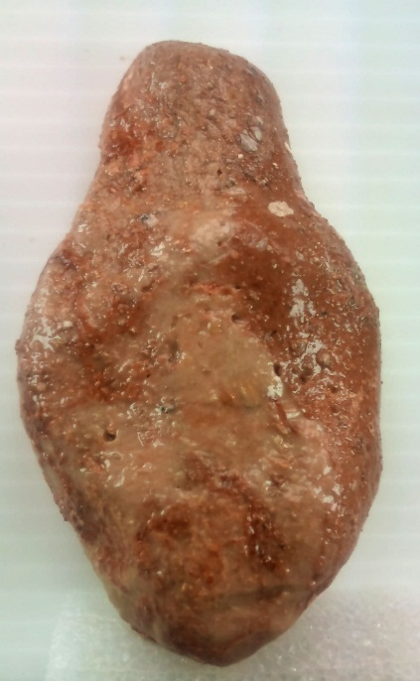 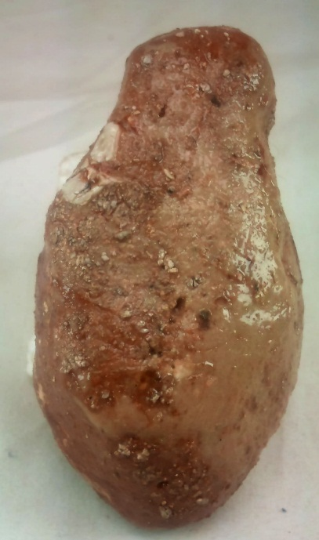 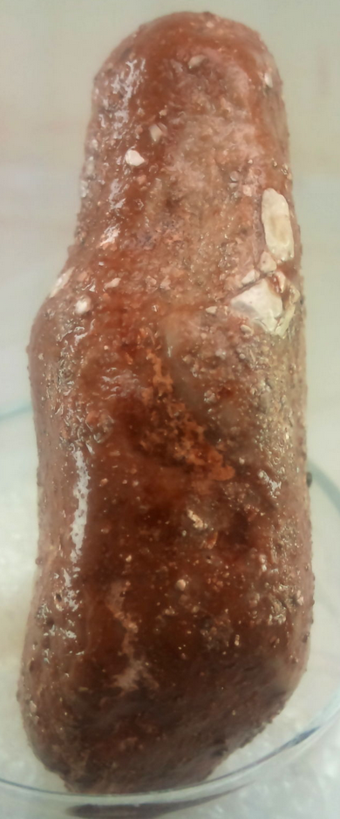 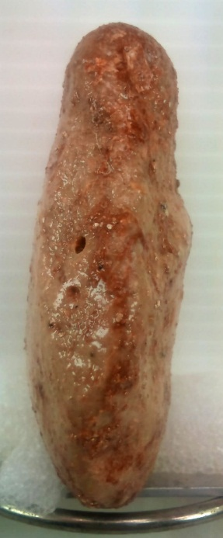

Figs. 1-5. **Israel-Lower Paleolithic Figurine-Silicified Sandstone-20,000 BCE**

**Case no.: 1**

**Accession Number:**

**Formal Label: Israel-Early Paleolithic Figurine-Silicified Sandstone-20,000 BCE**

**Display Description:**

“The discovery is exciting by any standard. Was found to the north of the Dead Sea about 15 km from its right [bank]. In a cave in which an archaeological excavation is carried out. Dating to the beginning of the Paleolithic Stone Age. There are several figures engraved on it.” A product of *Homo Erectus*.

**LC Classification:** [GN772.32.I75](http://josiah.brown.edu/search~S7?/c1-SIZE+GN772.32.I75+S27x+2004/cgn++772.32+i75+s27+x+2004/-3,-1,,E/browse)

**Date or Time Horizon:** Paleolithic ca 20,000 BCE

**Geographical Area:** right bank of Jordan River, 15 km from Dead Sea

### Map:

**GPS coordinates:** unknown

**Cultural Affiliation:** Paleolithic

**Medium:** silicified sandstone

**Dimensions:** H 7.6 cm; W 4 cm

**Weight:** 103 grams; 3.55 oz

**Condition: “**The stone was cleaned professionally by the archaeological team, and then coated with a transparent lacquer that gives it protection and custody as well as beauty for display. This is the standard treatment offered by the museum and carried out by those who are involved in it and at a high level.”

**Provenance:**

“The incision of the present channel of Nahal (wadi) Zihor in the lacustrine sediments is manifested by a series of rock-cut and fluvial terraces (Q1–Q4) capped by gypsic-salic soils, which reflect the onset of the present, extremely arid climate. Over 100 find-spots and larger occurrences of prehistoric artifacts assigned to the Lower Paleolithic were discovered near Lake Zihor. On the basis of techno-typological and stratigraphic considerations, these assemblages are divided into two groups, the first of which may be contemporaneous with the lake, while the second is found mainly on the younger Q1 and Q2 terraces. It is estimated that the lake existed for more than 100,000 years” (Ginat, Zilberman, and Saragusti 2003).

**Discussion:**

**References:**

Ginat, H., Zilberman, E. and Saragusti, I., 2003. Early pleistocene lake deposits and Lower Paleolithic finds in Nahal (wadi) Zihor, Southern Negev desert, Israel. *Quaternary Research*, *59*(3), pp.445-458.